Ex No : 11 Practice with CI/CD (Continuous Integration and Continuous Deployment)
Date :

Aim
To understand and implement the principles of Continuous Integration (CI) and Continuous Deployment (CD) by automating code building, testing, and deployment using a version control system and CI/CD pipeline.
Requirements
- A GitHub/GitLab/Bitbucket account
- A sample application (e.g., simple Python/Node.js/Java project)
- CI/CD tool (e.g., GitHub Actions, GitLab CI, Jenkins, or CircleCI)
Procedure :
Step 1: Setup Version Control
- Create a repository on GitHub/GitLab.
- Push a sample application code to the repository.
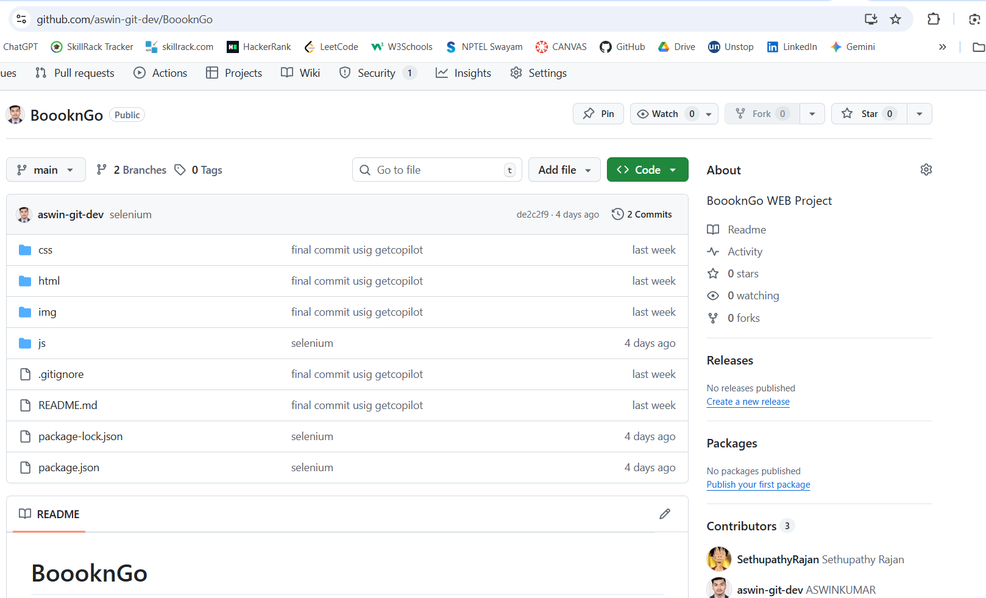
Step 2: Configure Continuous Integration (CI)
- Create a pipeline configuration file (e.g., .github/workflows/ci.yml for GitHub Actions).
- Define steps for:
  - Installing dependencies
  - Running build commands
  - Executing automated tests
- Commit and push the configuration file.
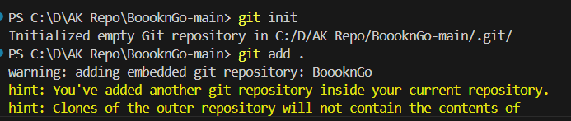
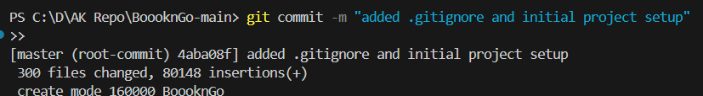
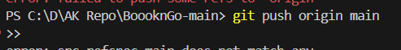
Step 3: Run the CI Pipeline
- Push changes to the repository.
- Observe pipeline execution in the CI/CD tool’s dashboard.
- Verify build and test results.
Step 4: Configure Continuous Deployment (CD)
- Extend the pipeline configuration to include deployment steps.
- Setup environment secrets (API keys, credentials).
- Define steps to deploy the application (e.g., deploy to Heroku, AWS, or a Docker container).
Step 5: Trigger Deployment
- Push changes to the main branch.
- Monitor the pipeline execution.
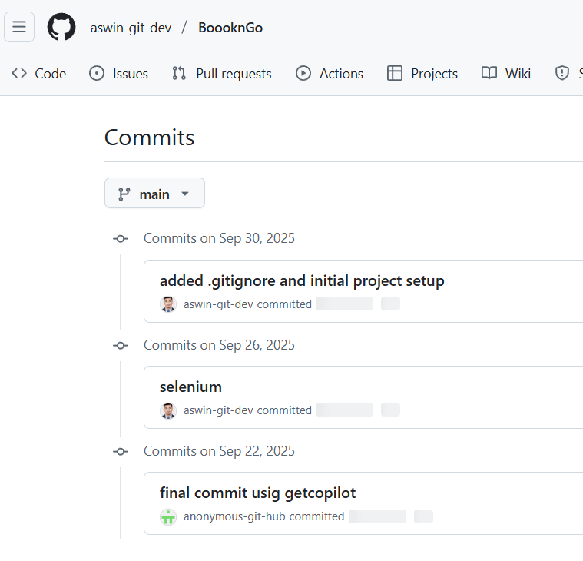

Result:
Thus, Successfully practiced CI/CD by automating build, testing, and deployment of an application. This experiment demonstrates how CI/CD ensures reliable, fast, and error-free software delivery.

